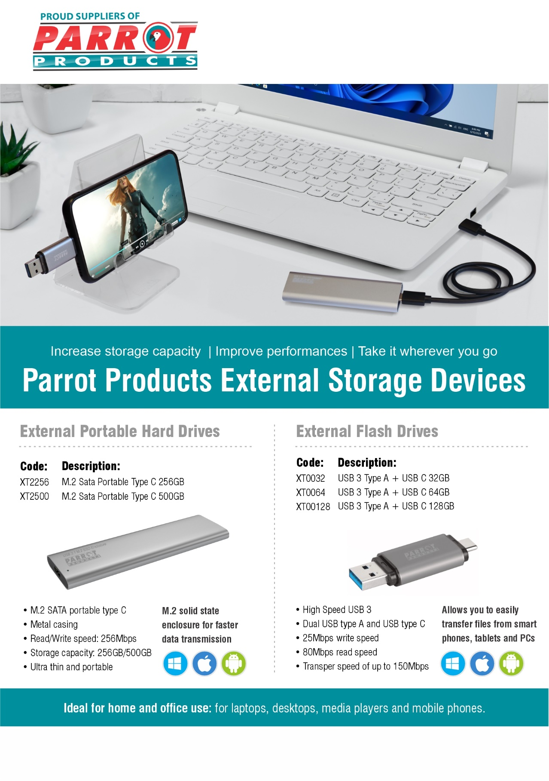dd

**R.R.P Ex.Vat**:

**R 1 303.00**

**R 2 135.50**

**R.R.P Ex.Vat:**

**R 180.50**

**R 259.00**

**R 413.50**

For more information contact us on

Tel: 000 000 0000 / Email: info@companyname.co.za / Website: www.companyname.co.za