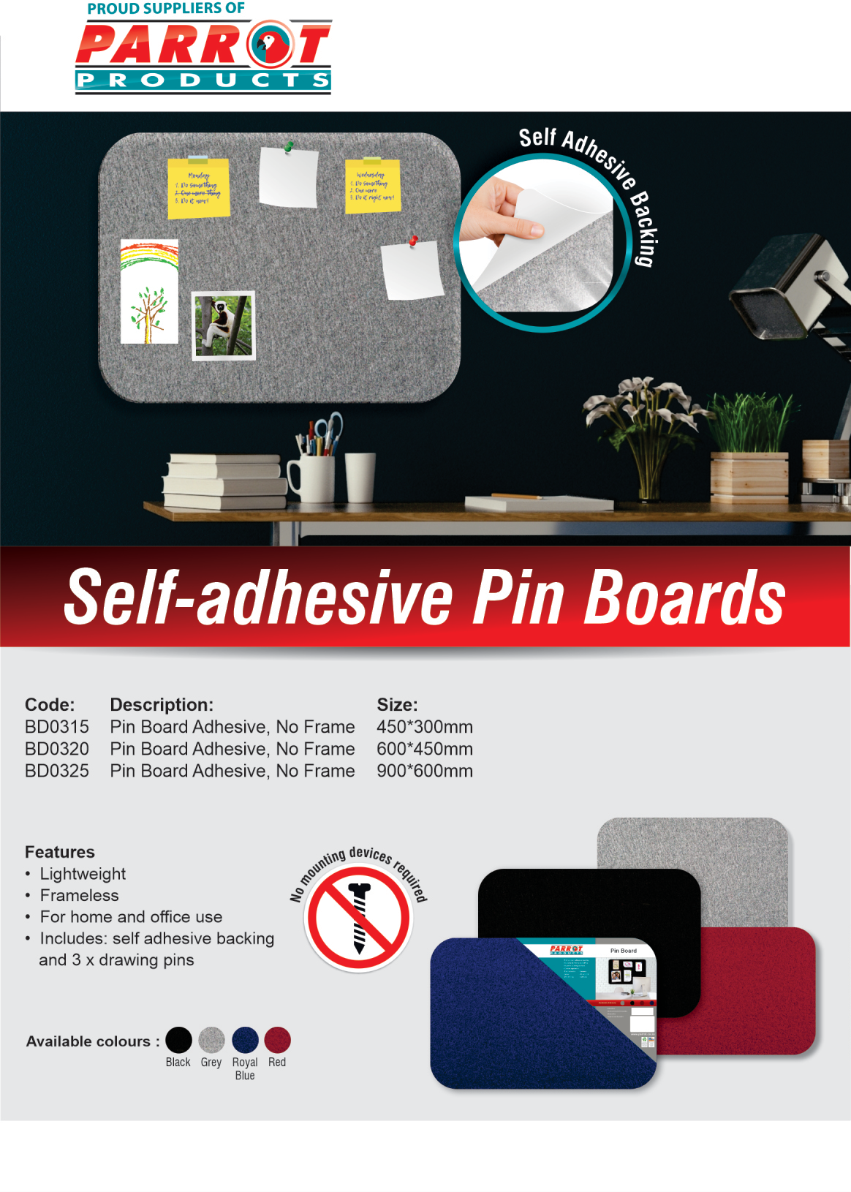

R.R.P. ex.VAT:

R 67.50
R 127.50
R 261.00

For more information contact us on:
Tel: 0123 456 8910 / Email: info@companyname.co.za / Website: www.companyname.co.za

