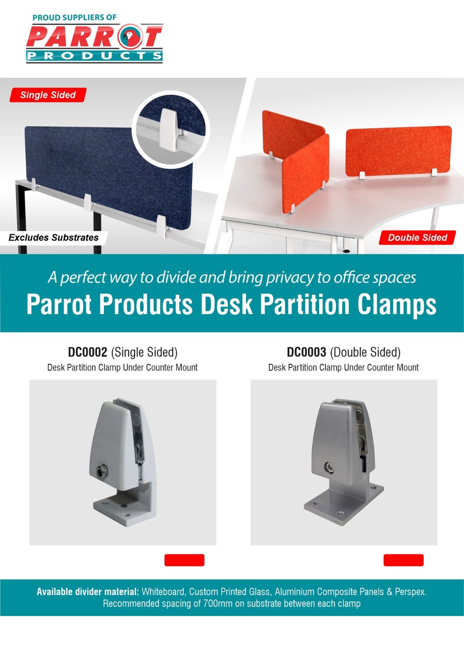

**[Buy Now](https://www.parrot.co.za/product/sku/DC0003&desk-partition-clamp-under-counter-mount-double-sided)**

R.R.Price Ex.Vat: **R 103.00**

R.R.Price Ex.Vat: **R 93.00**

**[Buy Now](https://www.parrot.co.za/product/sku/DC0002&desk-partition-clamp-under-counter-mount-single-sided)**

For more information contact us on

Tel: 000 000 0000 / Email: info@companyname.co.za / Website: www.companyname.co.za