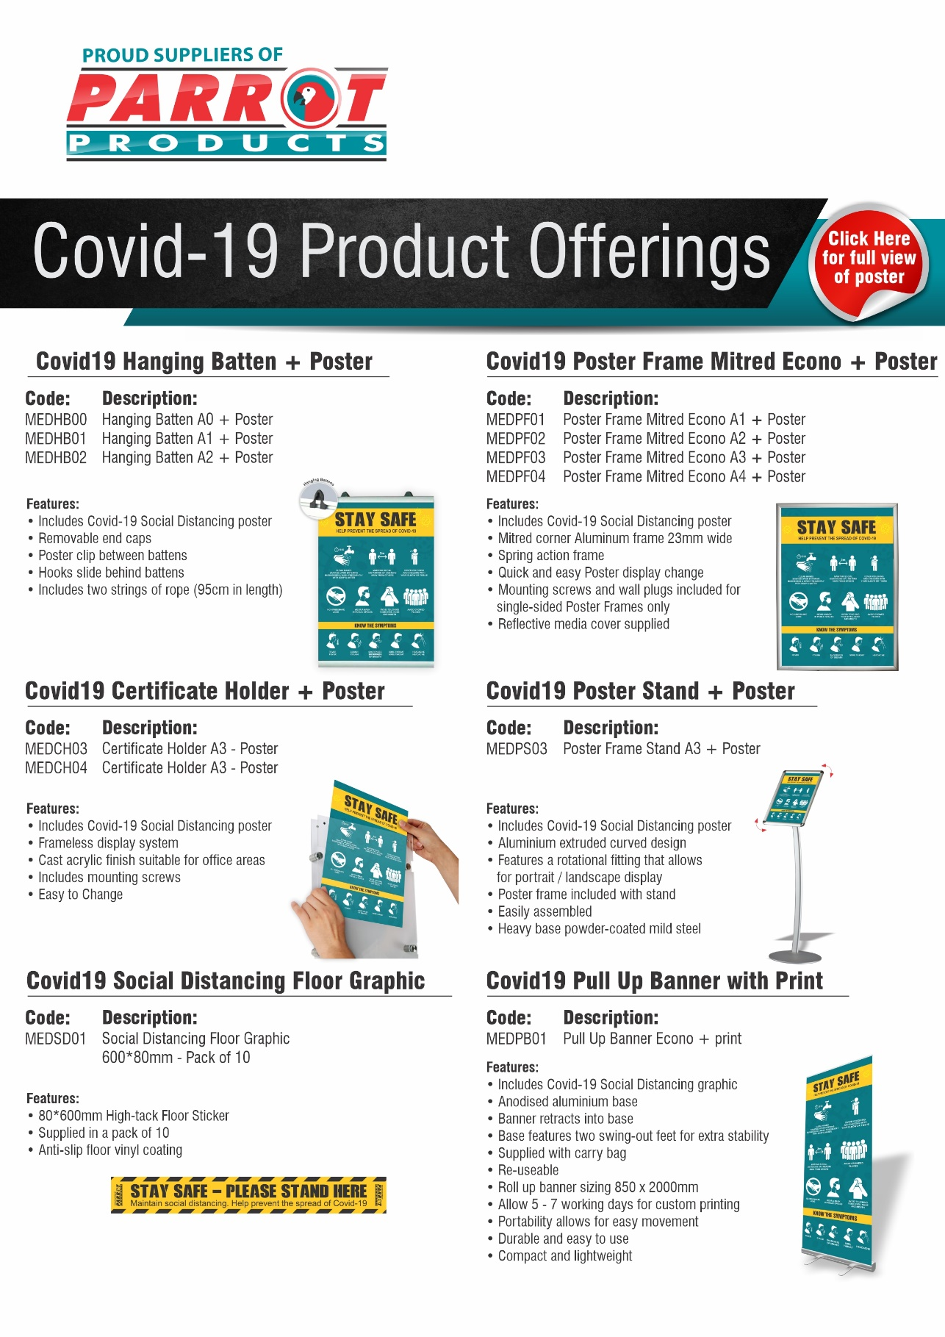

R.R.P ex.VAT:
R 768.00
R 478.00
R 321.00
R 246.00

R.R.P ex.VAT:
R 600.00
R 395.00
R 252.00

R.R.P ex.VAT:
R 2 820.00
R.R.P ex.VAT:
R 382.00
R 275.00

R.R.P ex.VAT:
R 650.00
R.R.P ex.VAT:
R 365.00

For more information contact us on:
Tel: 000 000 0000 / Email: info@companyname.co.za / Website: www.companyname.co.za

