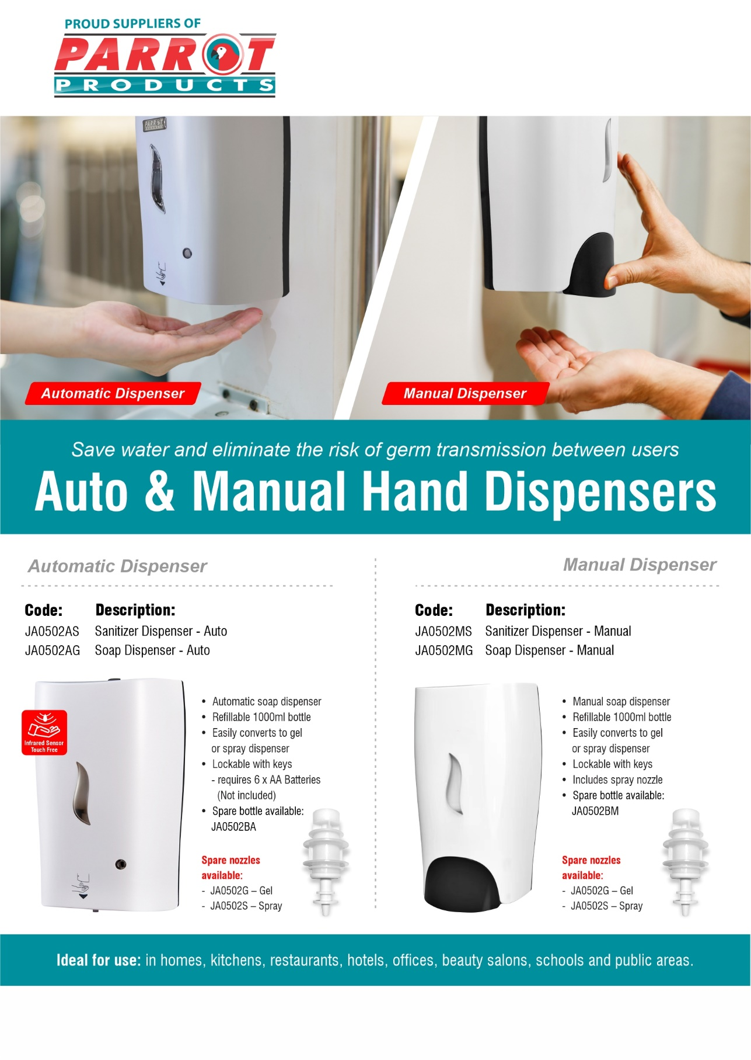dd

R.R.P Ex.Vat:

**R 858.50**

**R 829.50**

R.R.P Ex.Vat:

**R 333.50**

**R 304.00**

For more information contact us on

Tel: 000 000 0000 / Email: info@companyname.co.za / Website: www.companyname.co.za