Price Inc.Vat:

R 597.00
Price Inc.Vat:

R 379.00
Price Inc.Vat:

R 268.50

Price Inc.Vat:

R 740.00

Price Inc.Vat:

R 401.50

Price Inc.Vat:

R 275.50

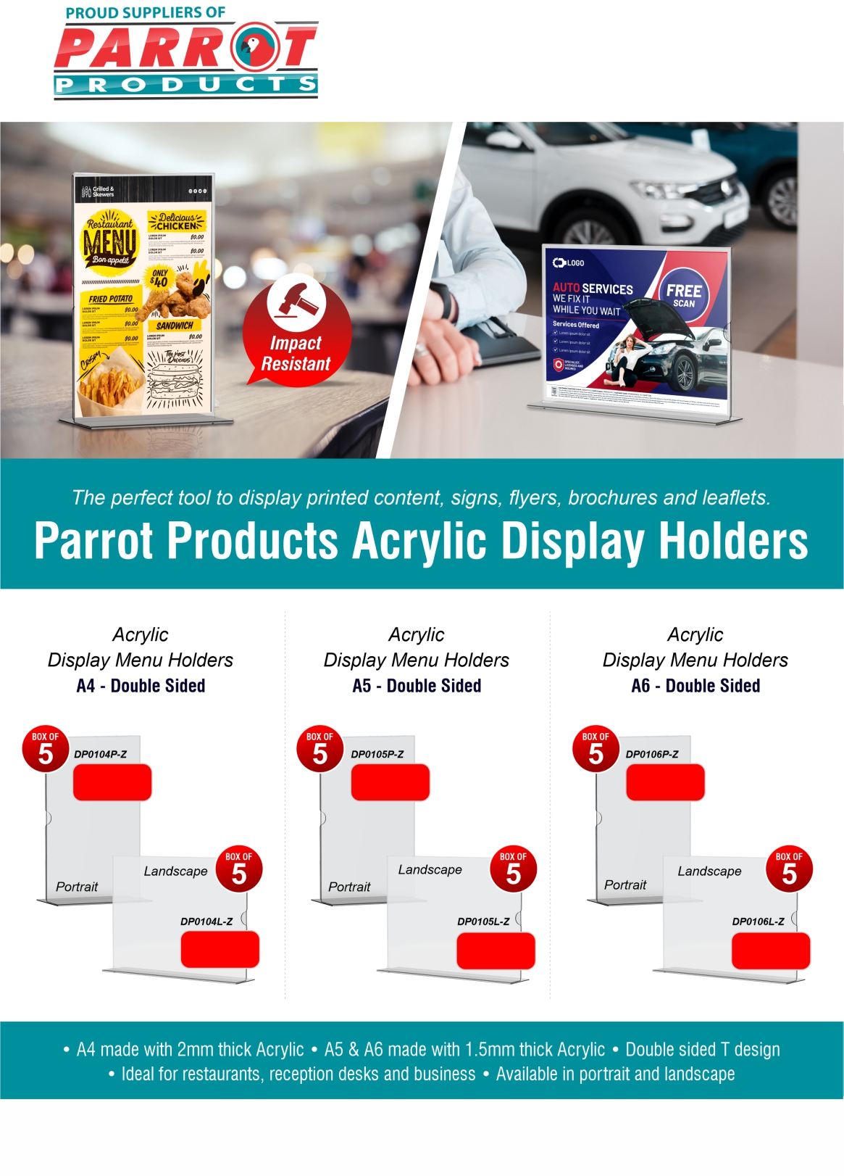

For more information contact us on
Tel: 000 000 0000 / Email: info@companyname.co.za / Website: www.companyname.co.za

