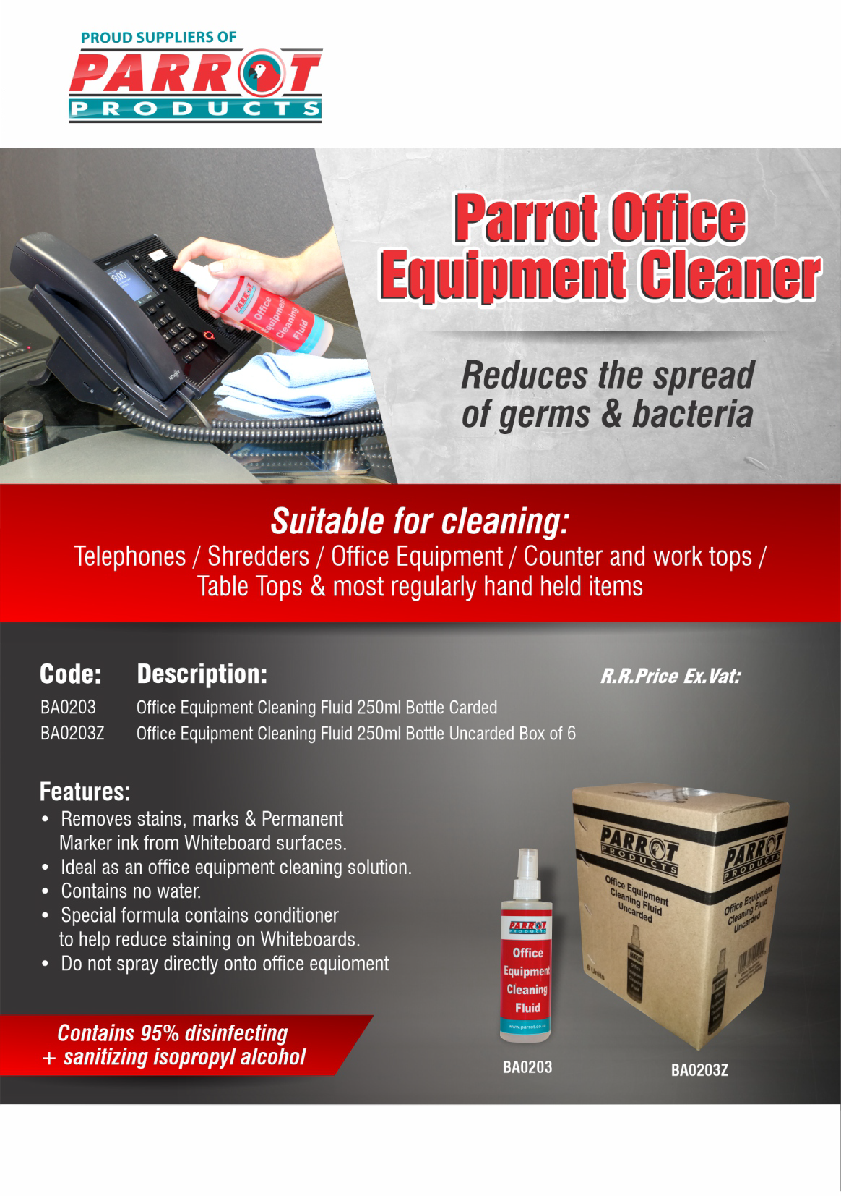

R 84.00 R 315.50

For more information contact us on:
Tel: 0123 456 8910 / Email: info@companyname.co.za / Website: www.companyname.co.za

