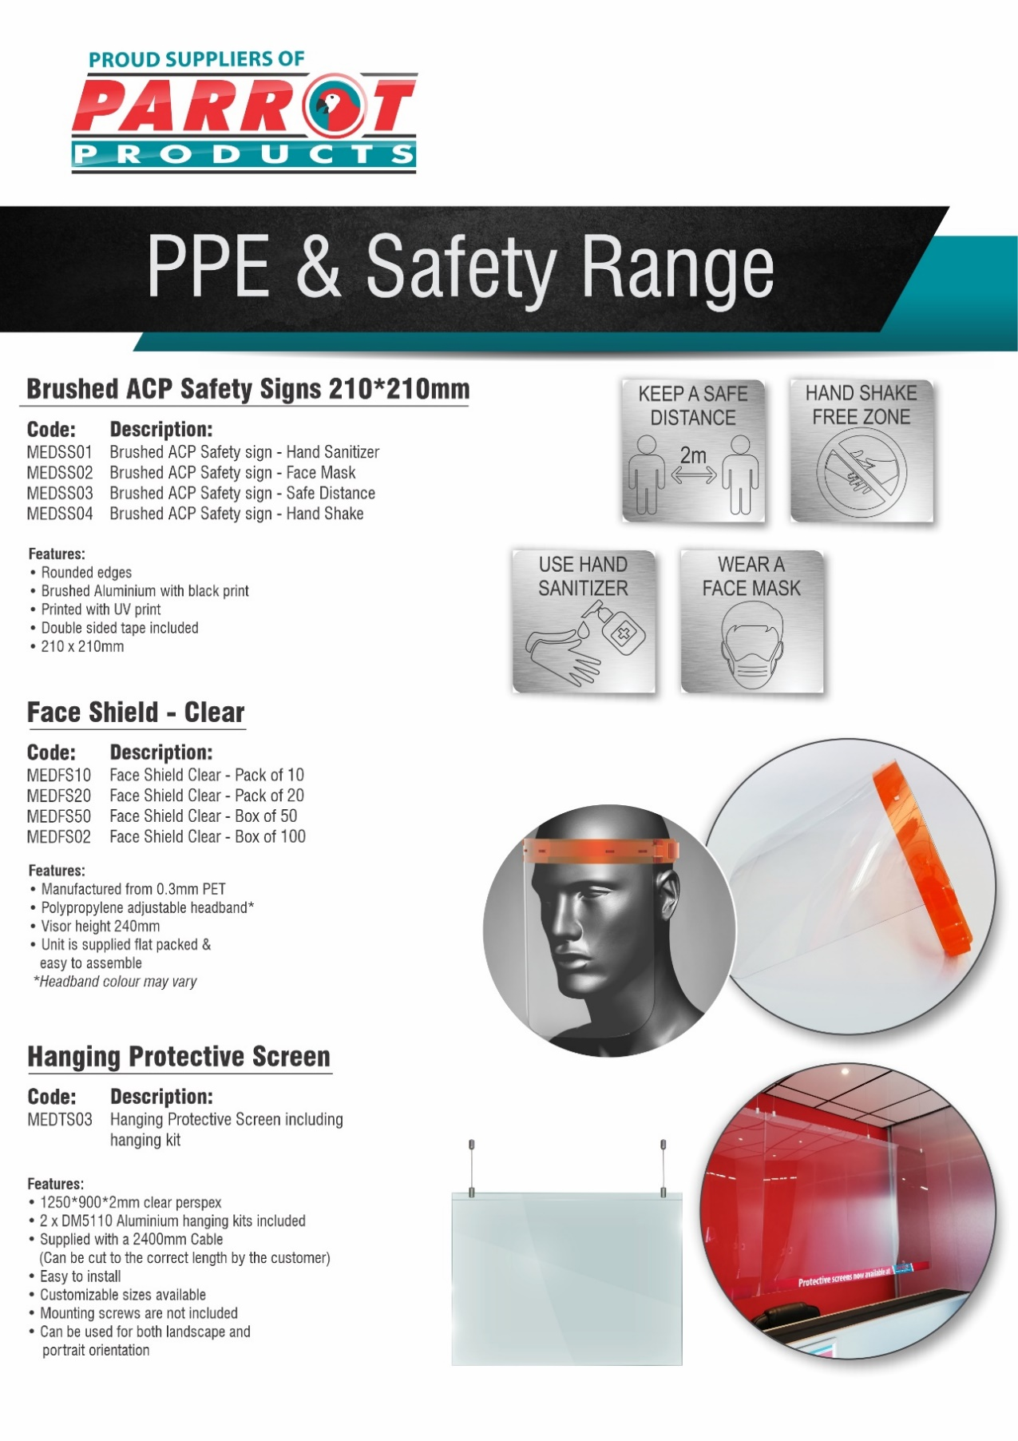

R.R.P ex.VAT:
R 54.50
R 54.50
R 54.50
R 54.50

R.R.P ex.VAT:
R 505.00
R 1 010.00
R 2 500.00
R 5 000.00

Click here
for assembly

R.R.P ex.VAT:
R 605.00

For more information contact us on:
Tel: 000 000 0000 / Email: info@companyname.co.za / Website: www.companyname.co.za

