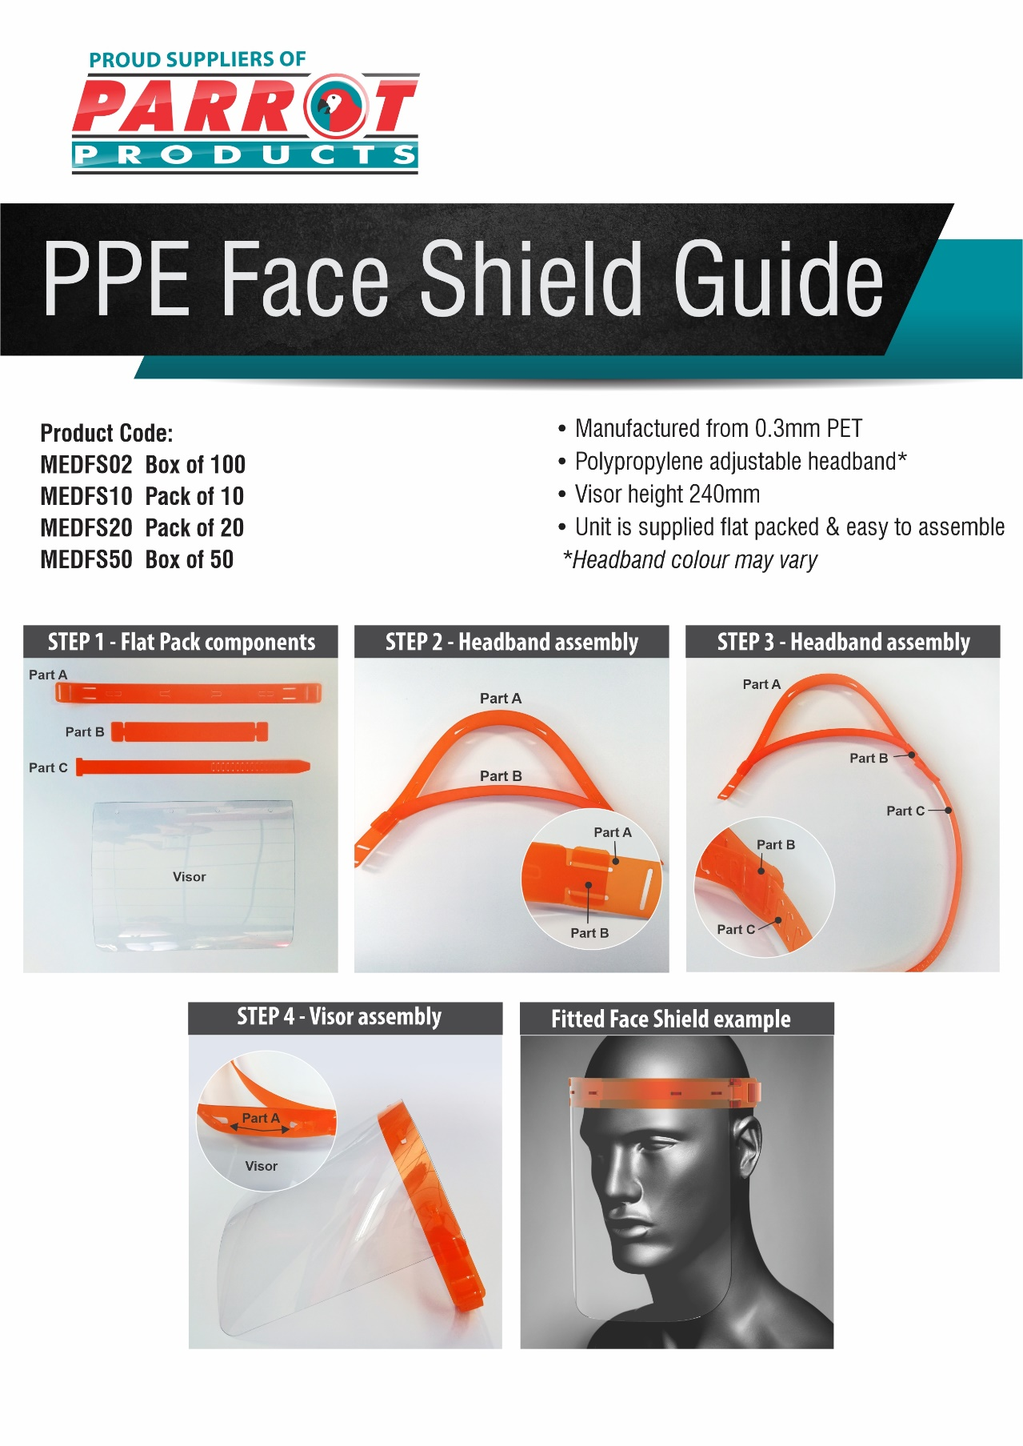

R.R.P ex VAT:
R 5 000.00
R 505.00
R 1 010.00
R 2 500.00

For more information contact us on:
Tel: 000 000 0000 / Email: info@companyname.co.za / Website: www.companyname.co.za

