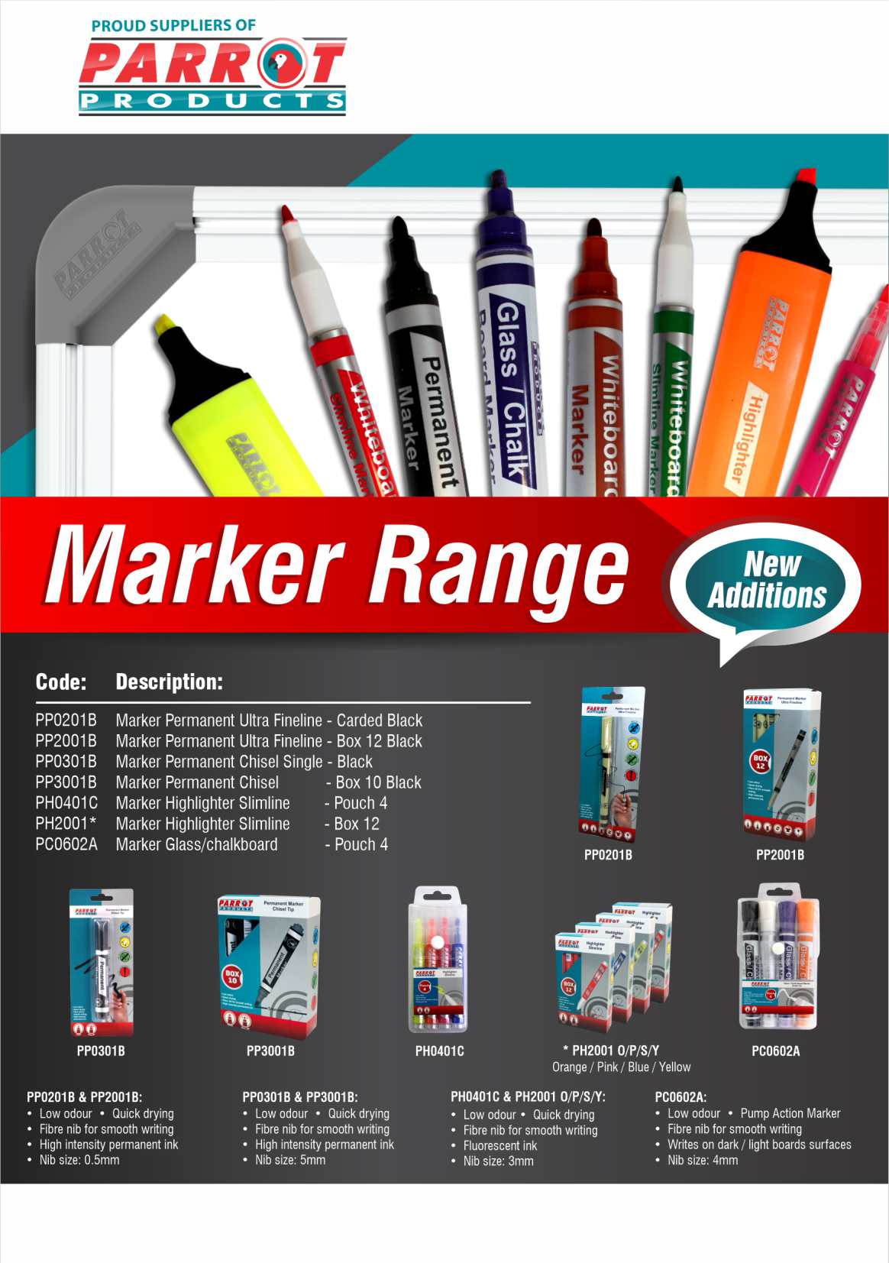

R.R.P. Ex Vat:
R 6.50
R 41.00
R 7.90
R 46.00
R 14.00
R 39.00
R 56.00

For more information contact us on:
Tel: 0123 456 8910 / Email: info@companyname.co.za / Website: www.companyname.co.za

