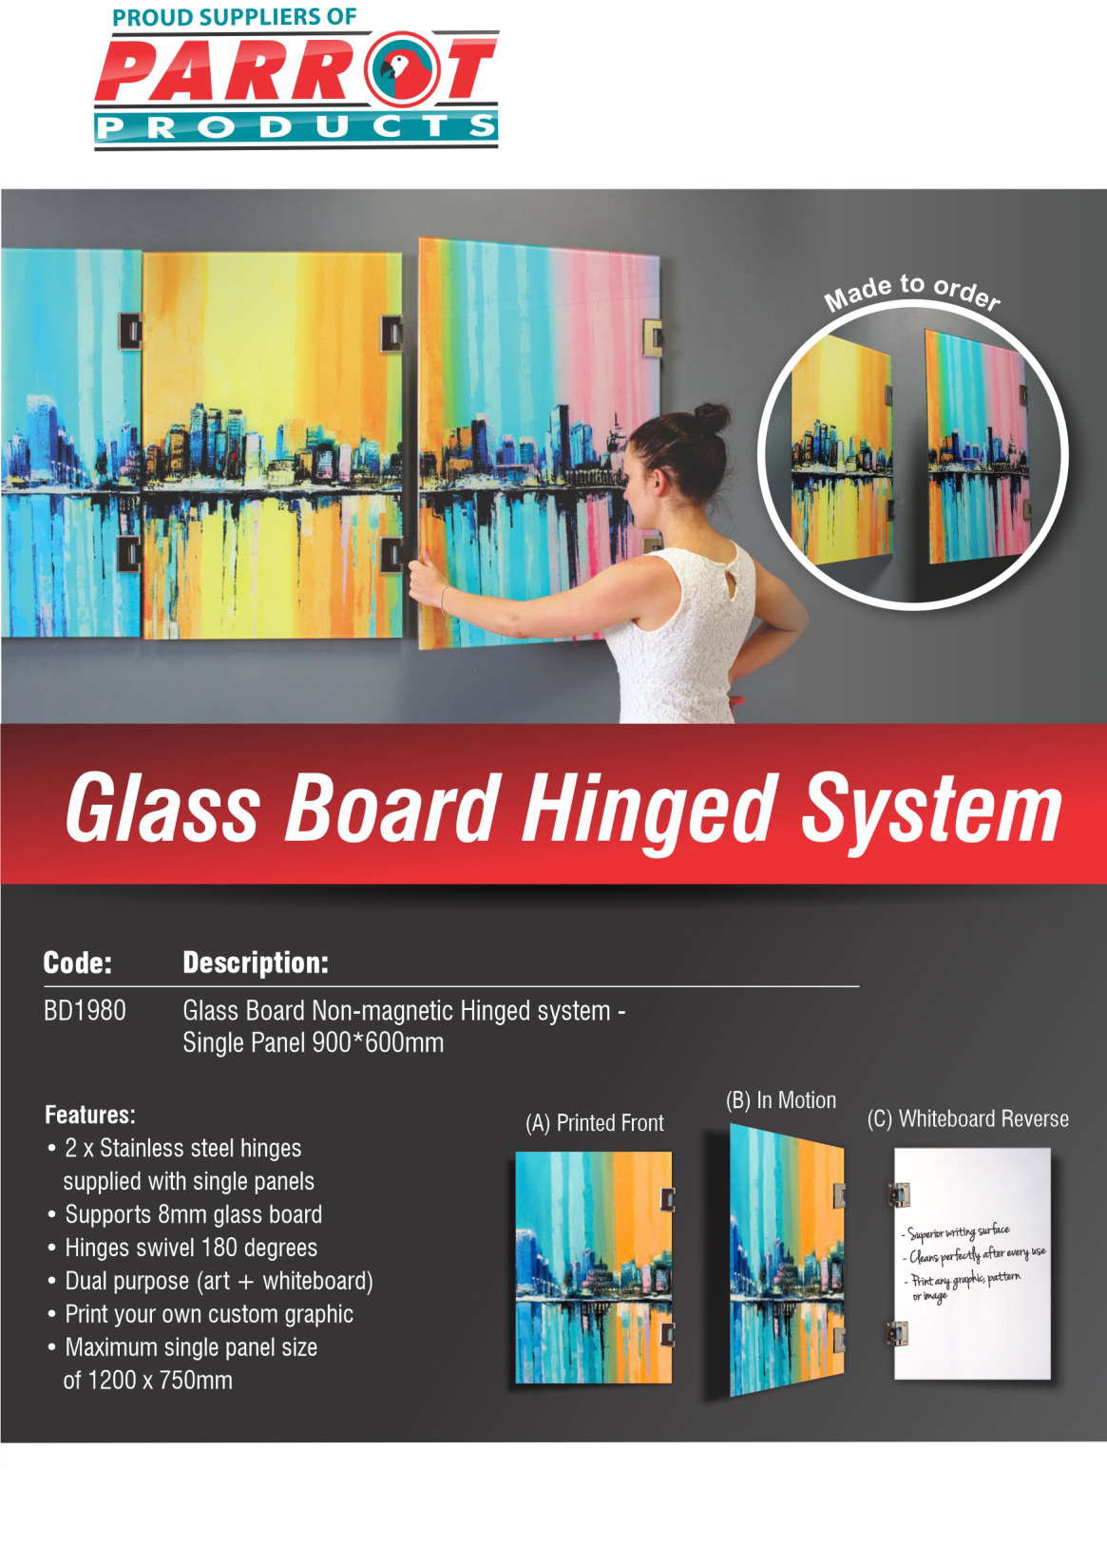

R.R.P. Incl. VAT
R 3 777.00

For more information contact us on:
Tel: 0123 456 8910 / Email: info@companyname.co.za / Website: www.companyname.co.za

